# ABC Inventory Management

# Test Scenario: Beta Test Scenario 2

Table of Contents

ABC Inventory Management 1

Test Scenario: Beta Test Scenario 2 1

Scenario Description 3

Version Control 3

User Group 3

Test Log 3

Steps 3

Result Screenshots 4

Feedback 14

# Scenario Description

This is the second Beta test scenario of ABC Inventory Management. The test was conducted by a third-party user to check if they could use the system as they wanted. No scripts were prepared so that the user had complete freedom to conduct any activity they wished for. All activities conducted by the user were logged when the user was conducting the tests. These logs were observed and documented in this document by the author. The basic information of the application and a user manual was provided to the user. The user was also given a warehouse staff password and a store staff password.

# Version Control

|  |  |  |  |
| --- | --- | --- | --- |
| Version Number | Date | Author | Description |
| 12.0 | 02/10/2018 | Shirish Maharjan | Initial Draft |
| 12.1 | 03/10/2018 | Shirish Maharjan | First Version (Iteration 6) |
| 12.2 | 10/10/2018 | Shirish Maharjan | Second Version (Iteration 6) |

# User Group

* Ishan Shrestha

# Test Log

## Steps

|  |  |  |  |
| --- | --- | --- | --- |
| Step | Test Action | Expected Results | Pass/Fail |
| 1. | Application is launched. | System displays the ‘Login’ Page with the Username and Password field empty. | Pass |
| 2. | User enters the provided warehouse staff username and password. | System waits for user to click on ‘Login’ button. | Pass |
| 3. | User clicks on the ‘Login’ button. | System grants access to the user and opens the Homepage with Warehouse Staff access. | Pass |
| 4. | User clicks on ‘Manage Staff’ button. | System displays the ‘Manage Staff’ page. | Pass |
| 5. | User clicks on the ‘Add New Staff’ button. | System displays the Add New Staff page. | Pass |
| 6. | User enters their details. | System waits for user’s action. | Pass |
| 7. | User clicks on the ‘Add’ button. | System adds the new staff to the database and displays an appropriate message. | Pass |
| 8. | User clicks on okay. | System displays the ‘Manage Staff’ page. | Pass |
| 9. | User enters their first name that they entered while adding a new staff. | System waits for user’s action. | Pass |
| 10. | User clicks on search. | System displays the details of the user entered. | Pass |
| 11. | User clicks on the ‘Edit’ button. | System displays the edit staff details page with the editable fields displayed | Pass |
| 12. | User clicks on the ‘Change Password’ link. | System displays a dialog box prompting user to enter the new password. | Pass |
| 13. | User enters desired new password. | System waits for user’s action. | Pass |
| 14. | User tries to click on update. | System disables the update button until user enters the new password twice. | Pass |
| 15. | User re-enters the password to confirm the new password. | System waits for user’s action. | Pass |
| 16. | User clicks on ’Update’. | System updates the user’s password and displays an appropriate message. | Pass |
| 17. | User clicks on the OK button in the dialog box which displayed the message. | System displays the edit staff page. | Pass |
| 18. | User clicks on the ‘Back’ button after pressing | System displays the ‘Manage Staff’ button. | Pass |
| 19. | User clicks on the ‘Homepage’ button. | System displays the Homepage. | Pass |

### Result Screenshots

**Step 1**

Application launched, and login page is displayed.

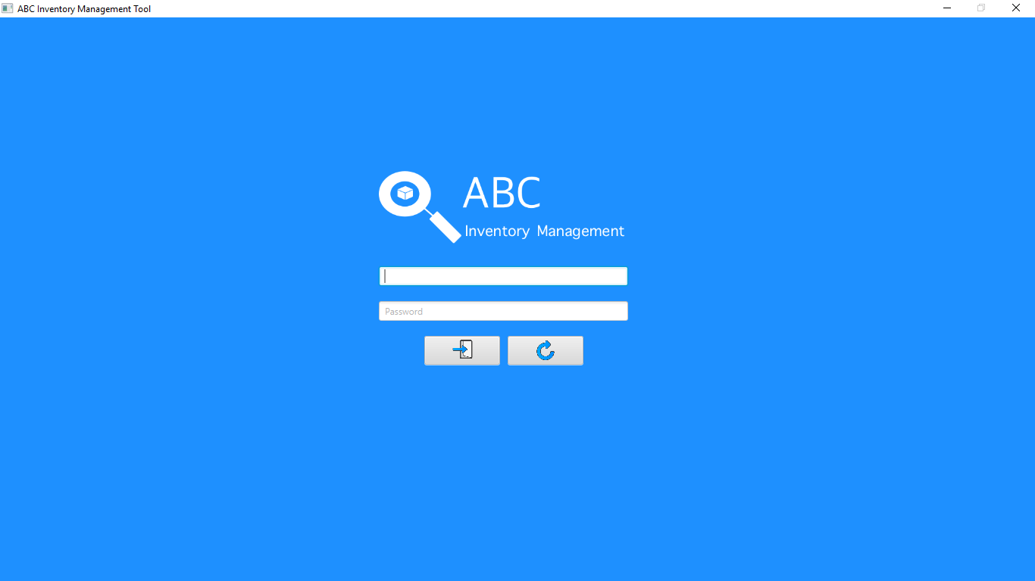

**Step 2**

Username and password are entered, and the system waits user to click on the ‘Login’ button.

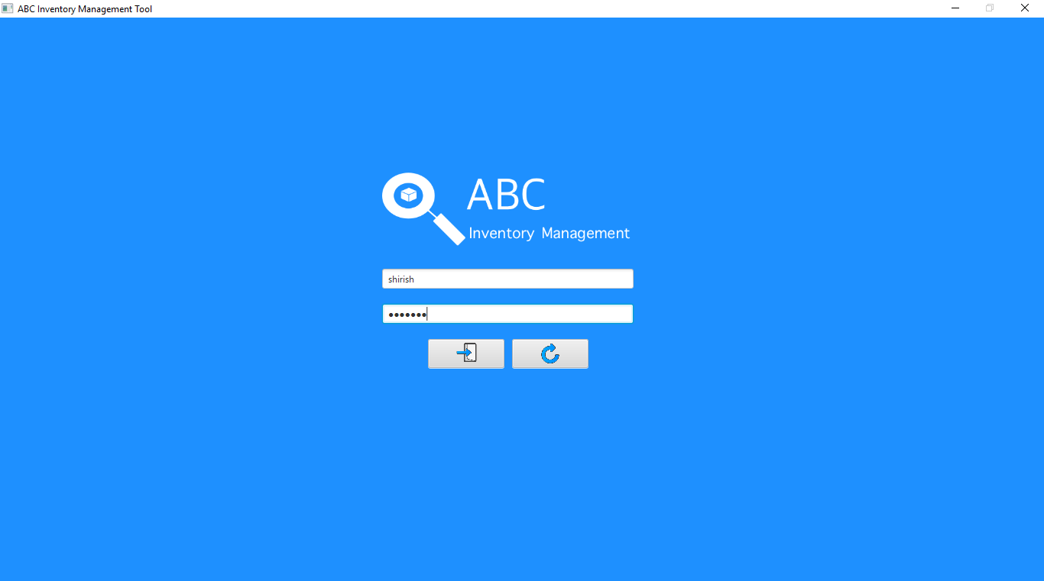

**Step 3**

After the user clicks on the login button, the homepage is displayed with warehouse staff access. The user then clicks on the ‘Manage Staff’ button.

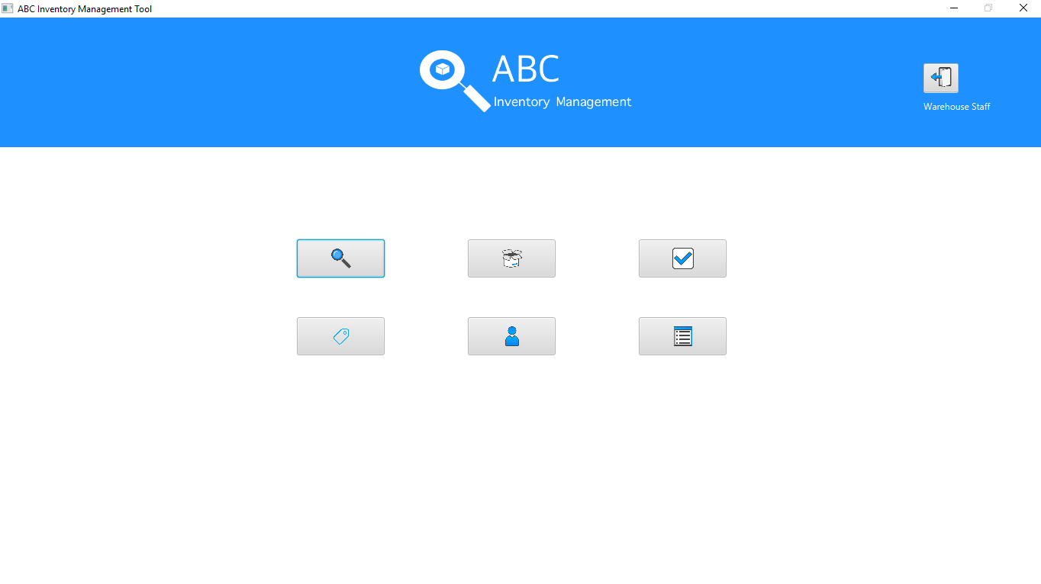

**Step 4**

After user clicks on the ‘Manage Staff’ button, the manage staff page is displayed. The user then clicks on the ‘Add New Staff’ button.

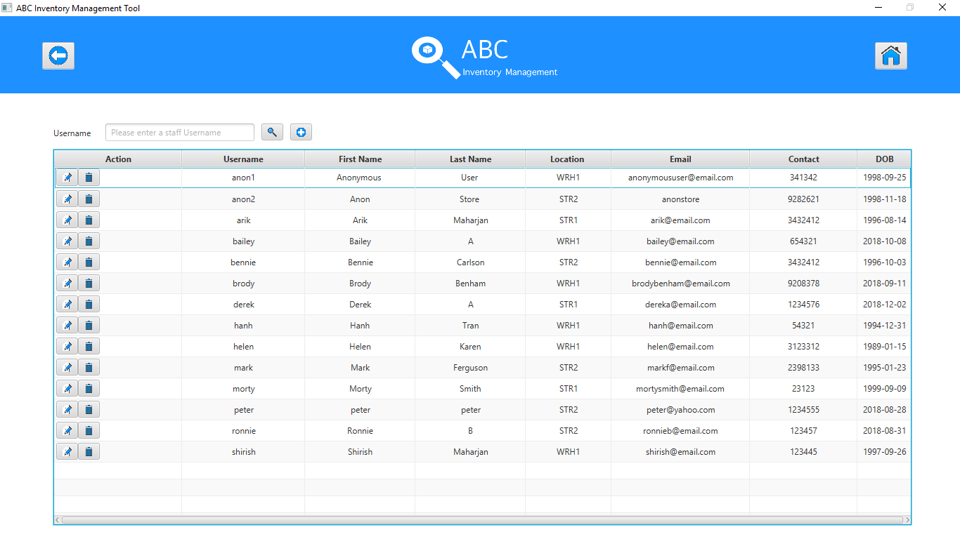

**Step 5**

The Add New Staff page is displayed after the user clicks on the ‘Add New Staff’ button.

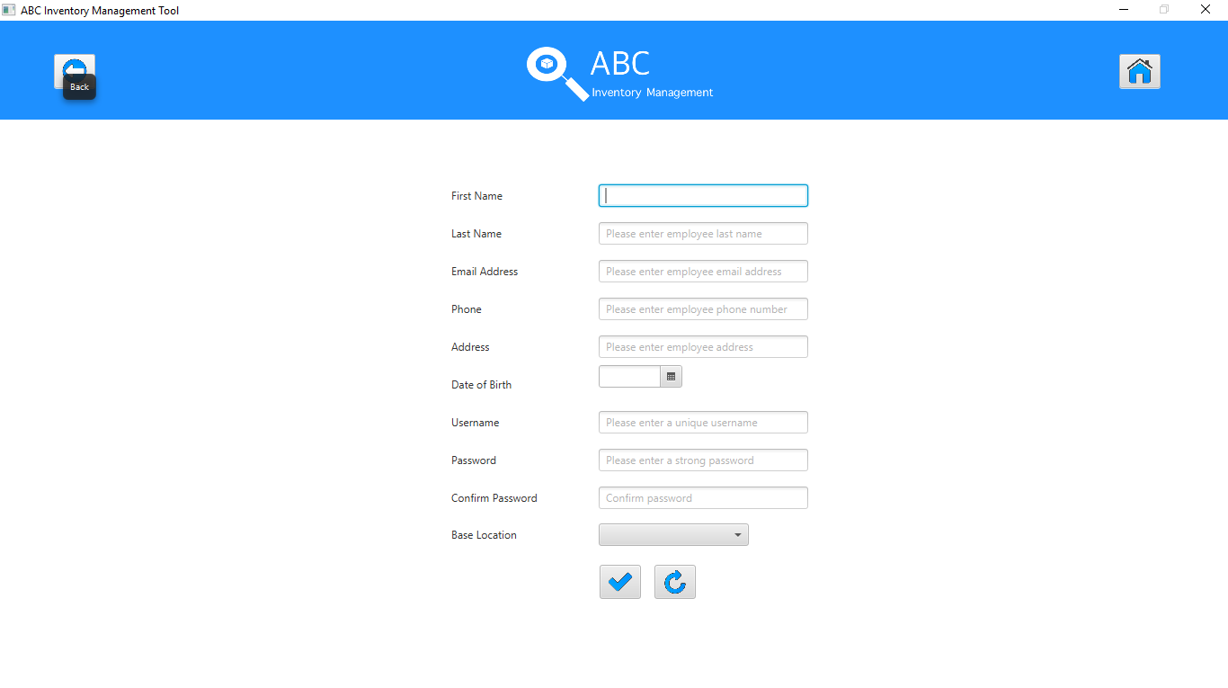

**Step 6**

The user then enters the details of the new staff.

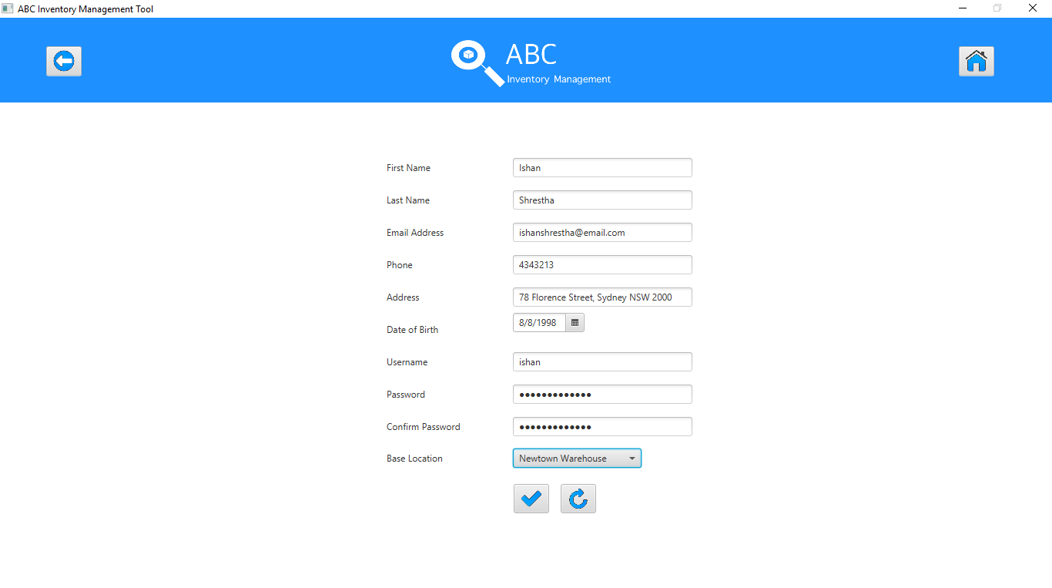

**Step 7**

After all details are entered, the user clicks on the ‘Add’ button after which the system displays a message saying the staff has been added.

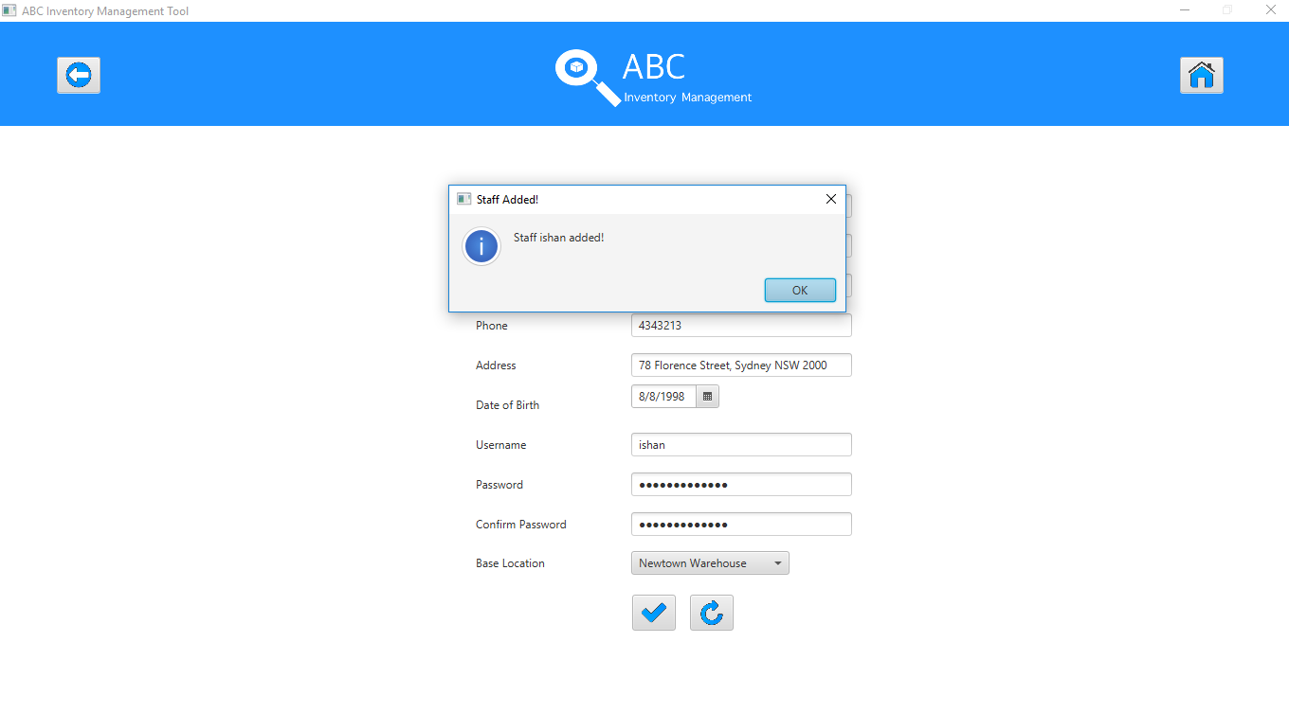

**Step 8**

When the user clicks on Ok on the message displayed, the system displays the manage staff page.

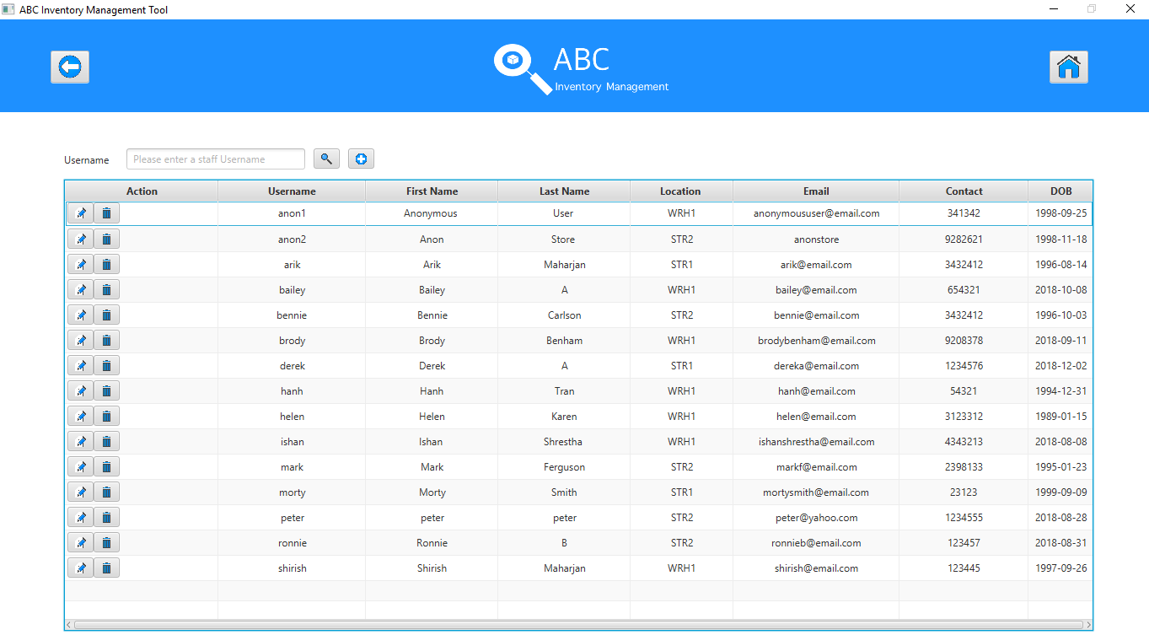

**Step 9**

The user enters the first name of the staff that was added.

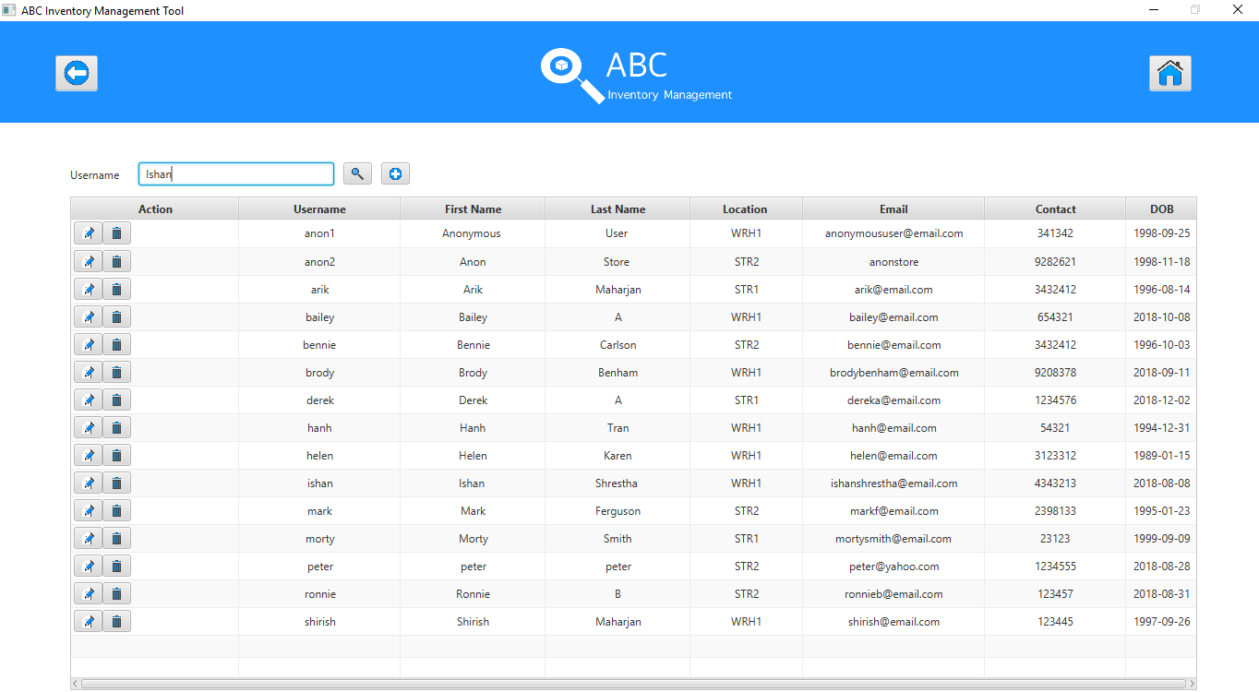

**Step 10**

The user clicks on the ‘Search’ button after which the system displays the staff that match with the name entered. (In this case there is only staff with the first name therefore only one entry is displayed.)

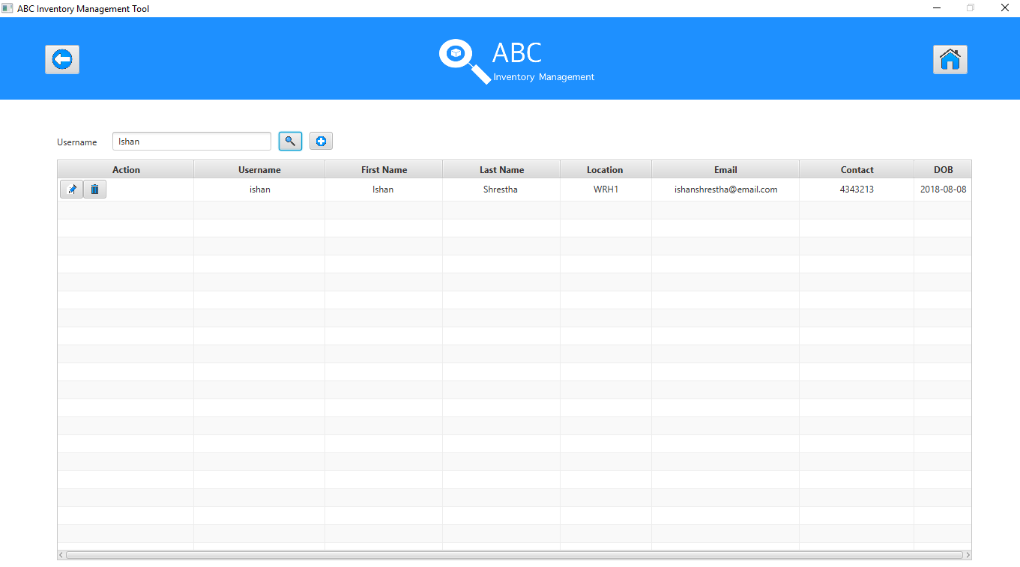

**Step 11**

The user then clicks on the ‘Edit’ button after which, the edit staff page is displayed where all editable fields are displayed too.

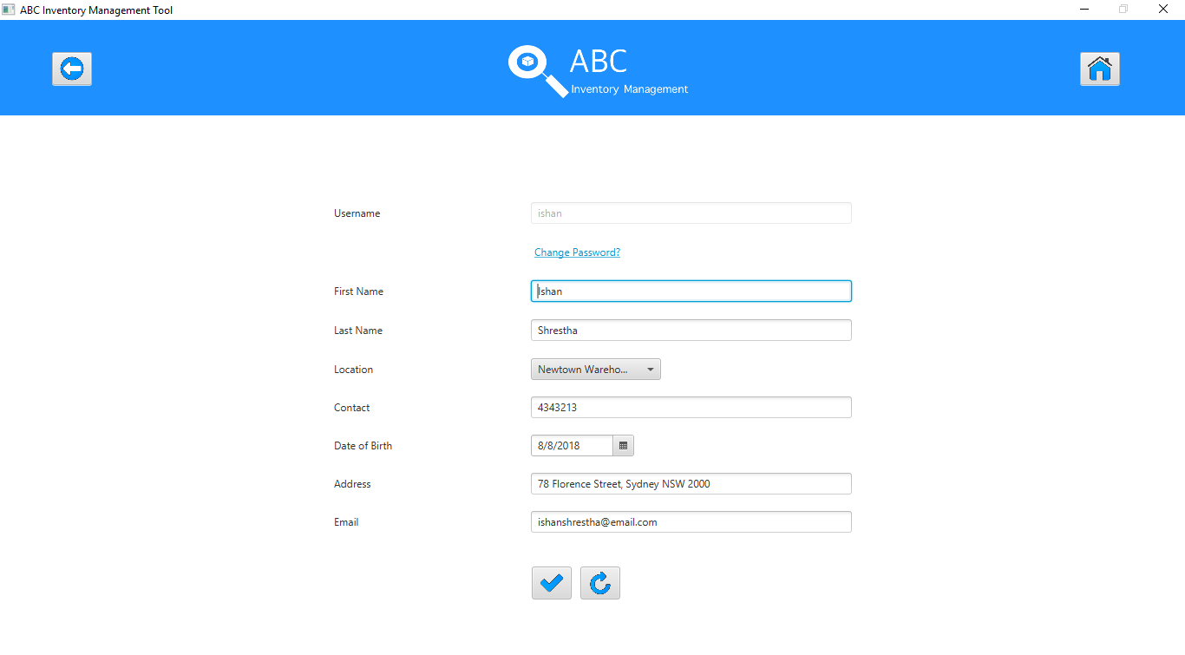

**Step 12**

The user when clicks on the ‘Change Password’ link, the dialog box to change the password is displayed.

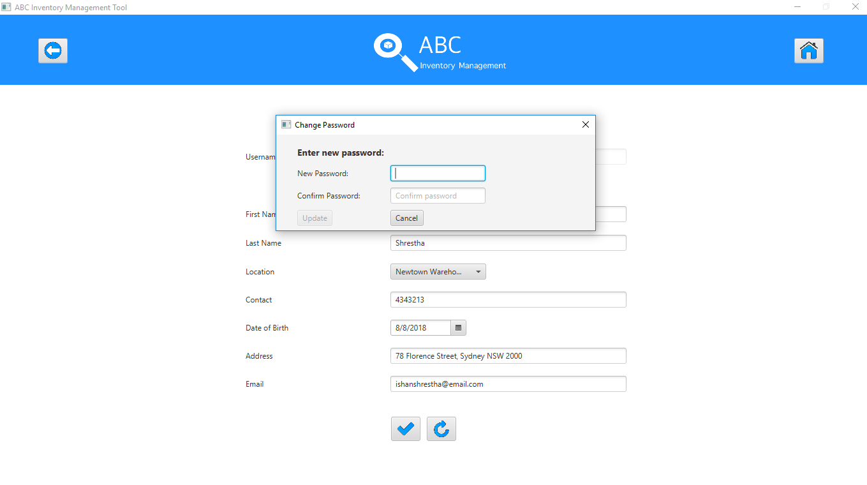

**Step 13**

The user enters the new password once and tries to update it, however the update button is disabled until both the new password and confirm password fields are entered.

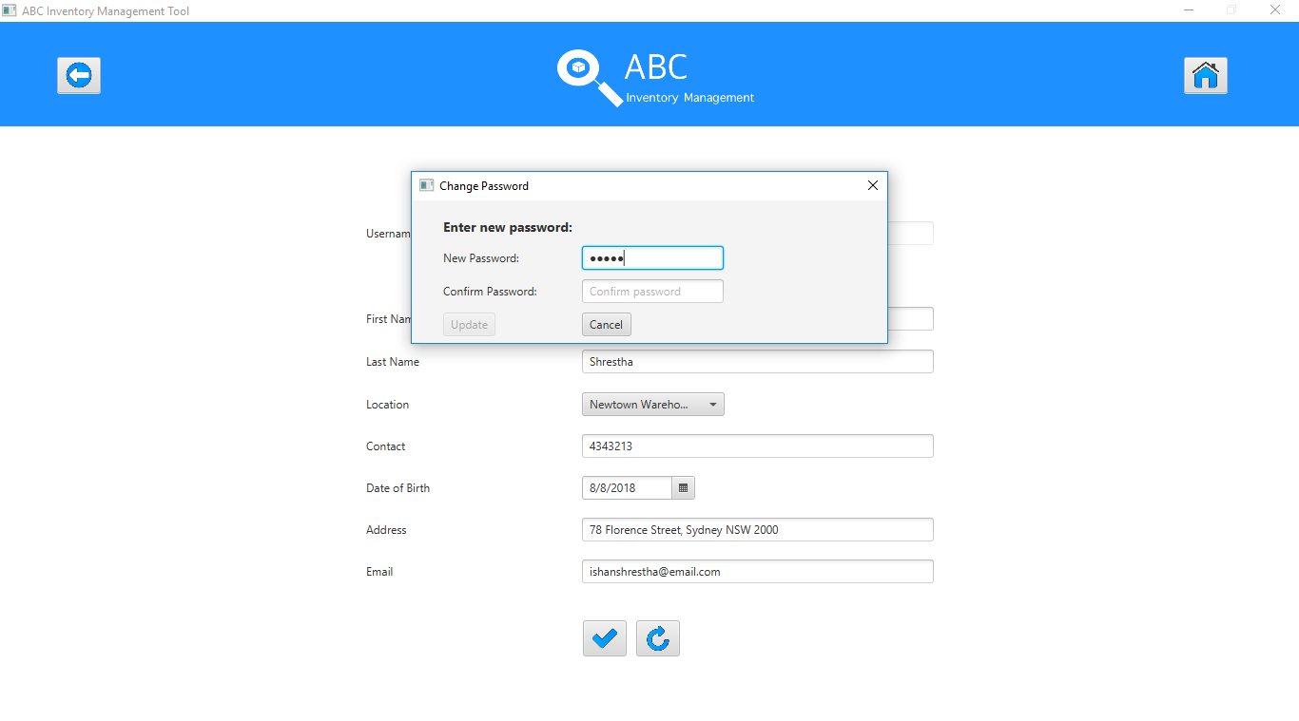

**Step 14**

The update button disabled when only one field is entered.

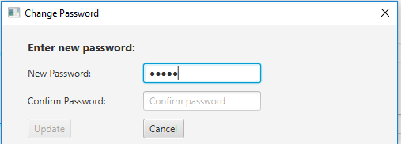

**Step 15**

When both fields are entered, the update button is visible.

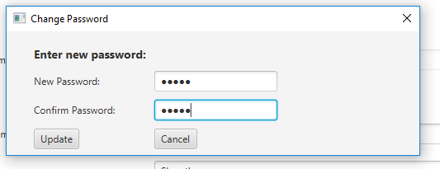

**Step 16**

After the user clicks on the ‘Update’ button, the system displays an appropriate message.

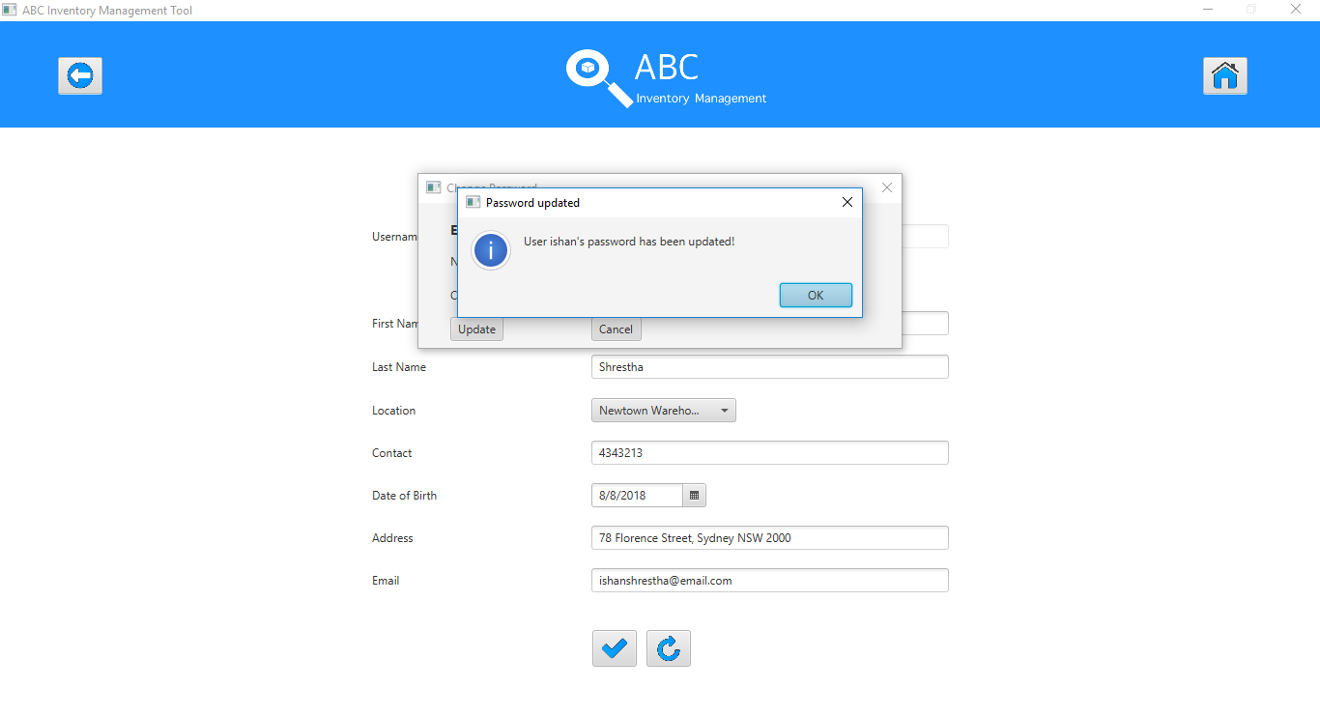

**Step 17**

After the user clicks on ‘Ok’ button, the edit staff page is displayed.

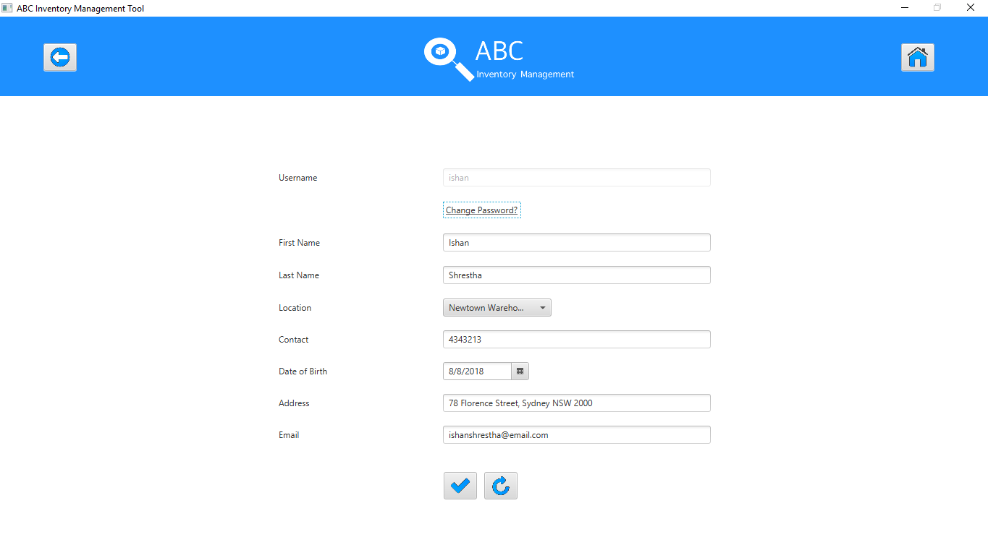

**Step 18**

After user clicks on the ‘Back’ button, the manage staff page is displayed.

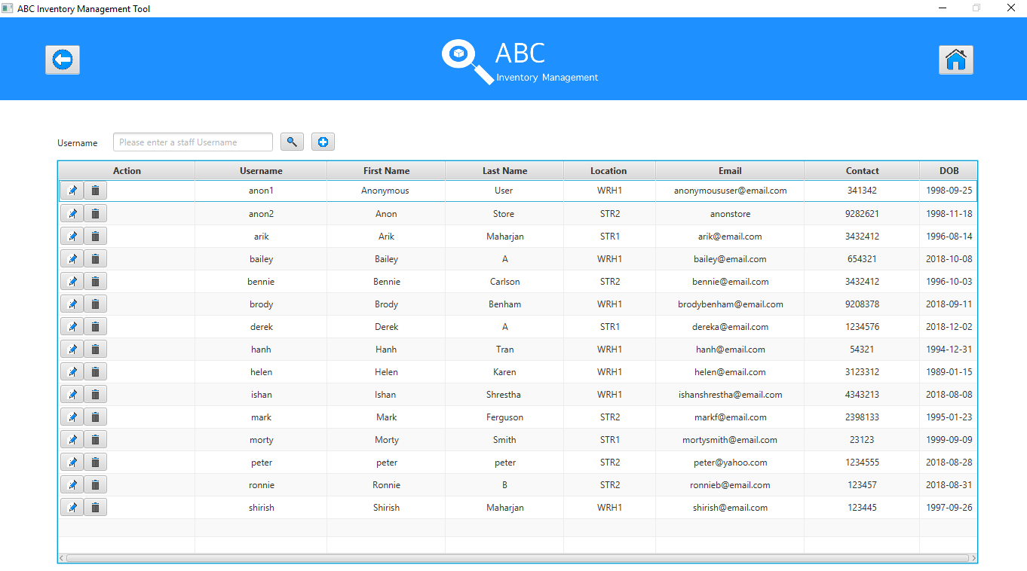

**Step 19**

After the user clicks on the ‘Homepage’ button, the system displays the Homepage.

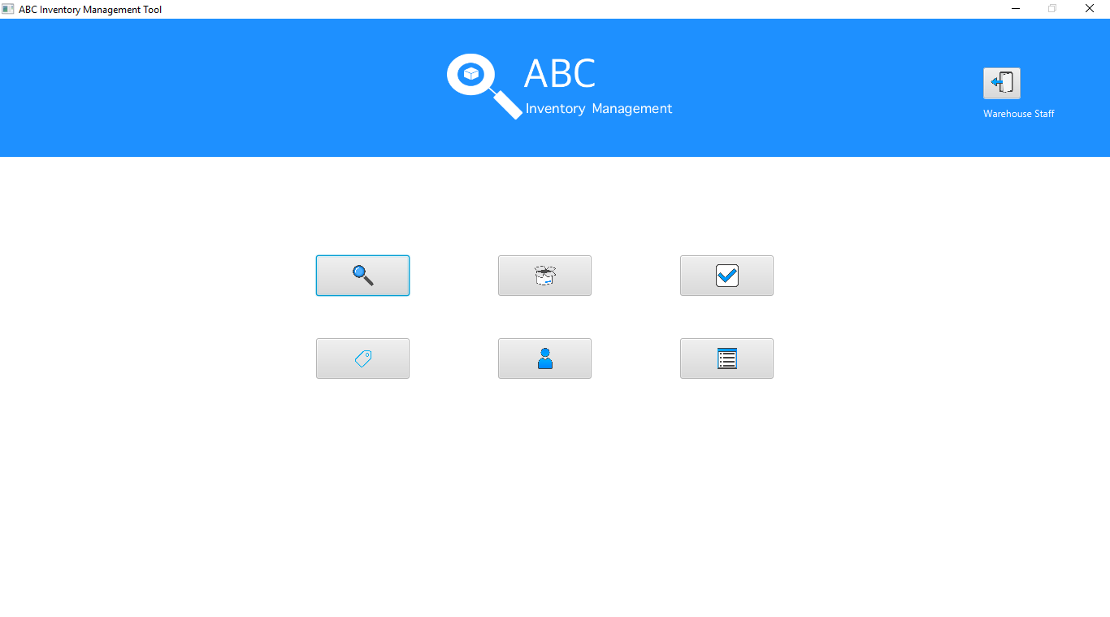

# Feedback

User did not have any feedback for the application.